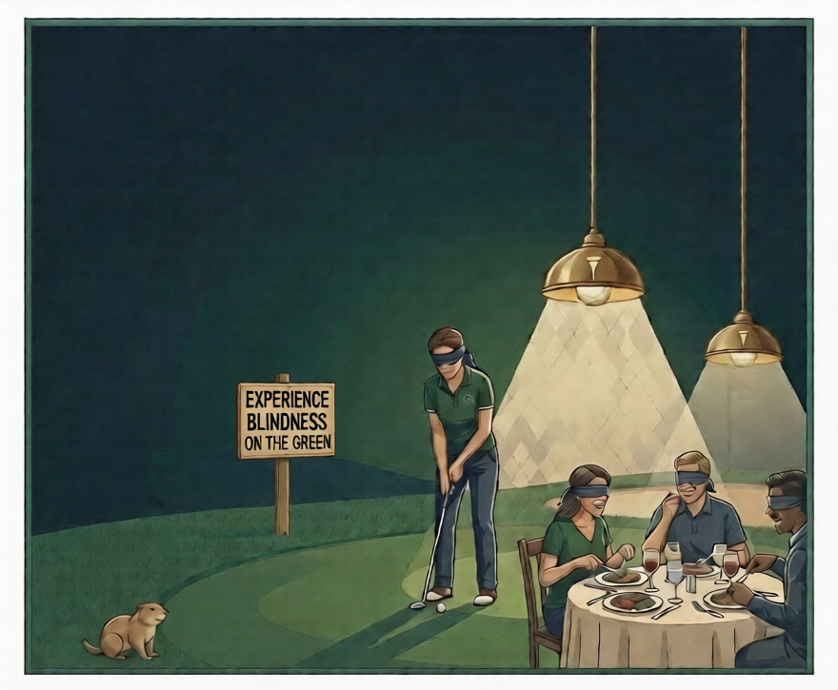
Tickets $50

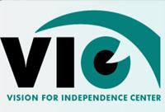
16th Annual
Dinner in the Dark
October 24th, 2026
4PM to 9PM, Dinner served at 6PM
Elks Golf & Country Club, Selah WA
For tickets, stop by our store
Vision for Independence Center
311 N 4th Street, Suite 104
Yakima WA 98901
or scan below
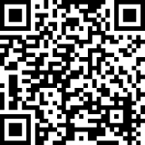
Join us for a fundraising dinner unlike any other: Experience blindness and low vision firsthand, while enjoying dinner and our putting contests on the green. You and your friends will never be the same!


Local Beer & Wine

Prizes and Raffles

Offering hope and maximizing quality of life for people with vision loss.

